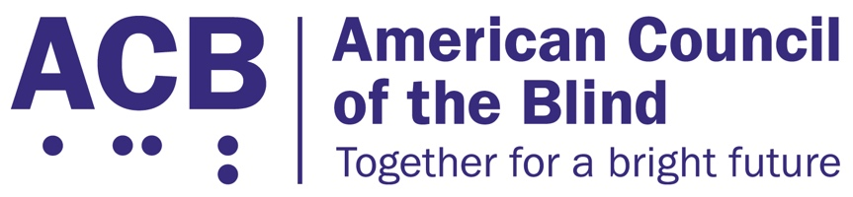
225 Reinekers Ln., Suite 660

Alexandria, VA 22314

Tel: (202) 467-5081

Fax: (703) 465-5085

June 10, 2026

Acting Attorney General Todd Blanche
U.S. Department of Justice
950 Pennsylvania Avenue, NW
Washington D.C. 20530

Dear Acting Attorney General Blanche:

The American Council of the Blind (ACB) writes these comments to express its deep frustration with the postponement of the 2024 published Title II website regulations. The Title II website regulations are something that have been long waited for by people with disabilities. The extension of the implementation was both inappropriate and harmful.

The American Council of the Blind is the nation’s leading member-driven organization of and for blind and low vision individuals. Founded in 1961 and comprised of thousands of members, ACB strives to increase the independence, security, equality of opportunity, and to improve the quality of life for all people who are blind or experiencing vision loss. Integral to our mission is ensuring equitable and accessible access to all websites and applications.

The creation of the Title II regulations had been in progress for many, many years. The process took more than a decade to even publish the Notice of Proposed Rule-Making (Notice). Then, after publication, covered entities had at least two years to implement the new regulations. Smaller municipalities had even more time than that; they had an additional year to implement the Title II regulations. This arbitrary postponement was not necessary. No new incidents or facts came to light that offered a reason for an extension of the new regulations. No kind of emergency came about to prompt a second look at the promulgated regulations.

The regulations had been carefully thought through by experts and had been commented on thoroughly by all who would be impacted. Furthermore, the rule-making process was carried out properly. Ample time was given for any and all entities to offer their opinions on the new regulations. Thousands of people and institutions submitted comments to the Notice when it was published by the Department of Justice (DOJ) in the Federal Register in 2023. People and entities of all backgrounds and perspectives had the opportunity and ability to submit comments that would be taken into account by the DOJ when promulgating final regulations. In fact, several of the exceptions outlined in the original Notice were amended as a result of comments that came in from the public. The formal Notice process outlined by the Administrative Procedures Act (APA) were carried out appropriately and successfully. No sufficient evidence was given by the DOJ or others to suddenly alter the outcome of the formal process.

Additionally, as advocates, we have observed that institutions covered by Title II of the Americans with Disabilities Act (ADA) have routinely asked for regulations. Although the ADA has always included coverage of websites as stated multiple times by both the Disability Rights Section of the DOJ and numerous court rulings, entities have often requested specific regulations to know how to appropriately make their websites accessible for people with disabilities. These regulations have done just that. A set of regulations as detailed in the 2024 publication specifically instruct Title II entities on how to make their websites accessible. Much of the standards mandated by the publication come from the Web Content Accessibility Guidelines (WCAG), an internationally recognized standard that has been used in the industry for many years. This standard is precisely what has routinely been requested by covered entities.

Access to websites is more important than ever. In 2026, much of what we do in life is conducted online. This increase in online activity was emphasized during the COVID-19 pandemic in 2020. Activities such as healthcare, education, and procuring legal documents is all conducted through web portals. This demonstrates the need for web access. If a person with a disability wants to be independent and engage in civic activities, Title II websites must be accessible. The regulations as developed will make this possible.

The importance of these regulations were highlighted by the number of entities who sought appointments with the Office of Information and Regulatory Affairs (OIRA) in 2026 with the news of a potential change or delay in the implementation of the regulations. Countless organizations requested OIRA meetings to talk directly with the Office of Management and Budget (OMB) to emphasize the urgent need to implement the promulgated Title II regulations. This outpour of meeting requests highlights the importance of the new regulations for millions of Americans with disabilities. In those OIRA meetings, advocates stressed the great need for the implementation of the Title II website regulations as soon as possible.

Once again, we hope to express our deep disfavor with the implementation of the interim final rule published on April 20, 2026. Website access is far too important to postpone any longer. Please feel free to contact me with any follow-up questions. I can be contacted at cstanley@acb.org or at (202) 559-2041.

Sincerely,

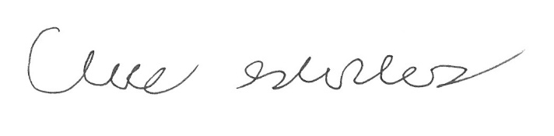

Claire Stanley, J.D.
Director of Advocacy and Governmental Affairs

